**Castel-Bloom, Orly (1960--)** Born in Tel Aviv to Egyptian Jewish parents, the Hebrew author Orly Castel-Bloom studied film at the prestigious Beit-Zvi Institute and at Tel Aviv University before publishing her first collection of short stories, *Lo rahok mi-merkaz ha-ir* (*Not Far from the City Centre*) in 1987. Her stories and novels have been translated into eleven languages and have won critical acclaim in Israel and abroad. She has been awarded several domestic and international literary prizes, including the Prime Minister's Prize (1994, 2001, and 2011) and the French WIZO Prize (2005). From the beginning of her literary career, her writing excited the admiration and the ire of Israeli readers and literary critics, prompting a debate between those who considered her sparse, colloquial, and at times slangy Hebrew as fresh and true to life, and those who derided it as superficial and inadequately literary. The latter critics even coined a phrase to describe her use of language, '*ivrit raza*' ('thin Hebrew'), situating her squarely against the predominantly male torchbearers of Hebrew literature and their 'rich Hebrew'.Her reputation as a leading contemporary author was established with the publication of her notorious second novel, *Doli siti* (*Dolly City*, 1992).

***************

Considered a postmodern masterpiece, *Dolly City* blends tropes of modernism and postmodernism to depict a dystopian, nightmarishly violent city. Dolly, a doctor who lives there and performs questionable medical experiments on animals and humans, realizes that her city is ill and feels a responsibility to cure it; after some time, she dismisses this compulsion and shifts from an urgent need to repair her world to an indifferent acceptance of its corrosive disease. *Dolly City* garnered a positive international reception by critics who compared Castel-Bloom to Kafka and Bulgakov; UNESCO included the novel in its Collection of Representative Works. In Israel, the novel established her as one of the most fearless authors of her time. The revered critic Gershon Shaked claimed that Castel-Bloom had 'done nothing less than change the face of Hebrew fiction'.

Throughout the 1990s, the novels and stories that followed *Dolly City* continued to challenge the boundaries of literary convention and to defy readers' expectations both thematically and stylistically. Castel-Bloom's bold criticism, couched in narratives that mix fantasy and reality, was refreshing to her Israeli readers, and spawned a host of admiring imitations from young writers. However, *halakim enoshiyim* (*Human Parts*, 2002), a novel set during the second Intifada and written in a more realistic style than her previous works, disappointed some of her most ardent admirers, who considered it politically and stylistically regressive even though it retains the black humour and the sharp critical arrows typical of her oeuvre as a whole. Her following novel, *textil* (*Textile*, 2006), also confronts the Israeli situation more realistically than her earlier writings. While in earlier works, the author's wrath can be interpreted in universal terms thanks to their fantastic settings, in both these novels, her anger is clearly situated in and directed towards the particularities of Israeli society.

**References and further reading**

1. Cohen, Uri S. (2011) *Likro et Orli Kastel-Bloom* (*Reading Orly Castel-Bloom*). Tel Aviv: Ahuzat Bayit (Hebrew).
2. Grumberg, Karen (2011) 'An Architecture of Isolation: Orly Castel-Bloom,' in *Place and Ideology in Contemporary Hebrew Literature*. Syracuse: Syracuse University Press, 76-122.
3. Shiffman, Smadar (2009) 'Orly Castel-Bloom and Yoel Hoffmann: On Israeli postmodern prose fiction. *Hebrew Studies*, Vol 50, 215-227.
4. Shiffman, Smadar (2007) 'Orli Kastel-Bloom' ('Orly Castel-Bloom'), in *Dvarim she-roim mi-kan* (*Things You See from Here: David Grossman, Orly Castel-Bloom and Meir Shalev*)*.* Jerusalem: Carmel (Hebrew), 109-158.
5. Mendelson-Maoz, Adia (1998) 'Situatsyot kitsonyot zvaatiyot ve-groteskiyot bi-yitsiroteyhem shel Kastel-Bloom ve-Keret' ('Grotesque and Horrible Extreme Situations in the Works of Castel-Bloom and Keret'). *Dapim le-mehkar be-sifrut*, Vol. 11 (Hebrew), 269-95.

**List of Works**

**Story Collections**

*Lo rahok mi-merkaz ha-ir* (*Not Far from the City Centre*) (1987) Tel Aviv: Am Oved; (2007) Hakibbutz Hameuchad/Yavneh.

*Sviva oyenet* (*Hostile Surroundings*) (1989) Tel Aviv: Zmora Bitan.

*Sipurim bilti retsoniyim* (*Involuntary Stories*) (1993) Tel Aviv: Zmora Bitan.

*Radikalim hofshiyim* (*Free Radicals*) (2000) Jerusalem: Keter.

*Im orez lo mitvakhim* (*You Don't Argue with Rice*), (2004) Or Yehuda: Kinneret/Zmora Bitan.

*Hayey horef* (*Winter Life*) (2010) Bnei Brak: Hakibbutz Hameuchad: Siman Kriah.

**Novels**

*Heykhan ani nimtset* (*Where Am I*) (1990) Tel Aviv: Zmora Bitan.

*Doli siti* (*Dolly City*) (1992) Tel Aviv: Zmora Bitan; (2007) Hakibbutz Hameuchad/Yavneh.

*Ha-mina lisa* (*The Mina Lisa*) (1995) Jerusalem: Keter.

*Ha-sefer he-hadash shel orli kastel-bloom* (*Taking the Trend*) (1998) Jerusalem: Keter.

*Halakim enoshiyim* (*Human Parts*) (2002) Or Yehuda: Kinneret.

*Textil* (*Textile*) (2006) Tel Aviv: Hakibbutz Hameuchad/Siman Kriah.

**Children**

*Shneynu nitnaheg yafe* (*Let's Both Behave*) (1997) Jerusalem: Keter.

**Paratextual Material**

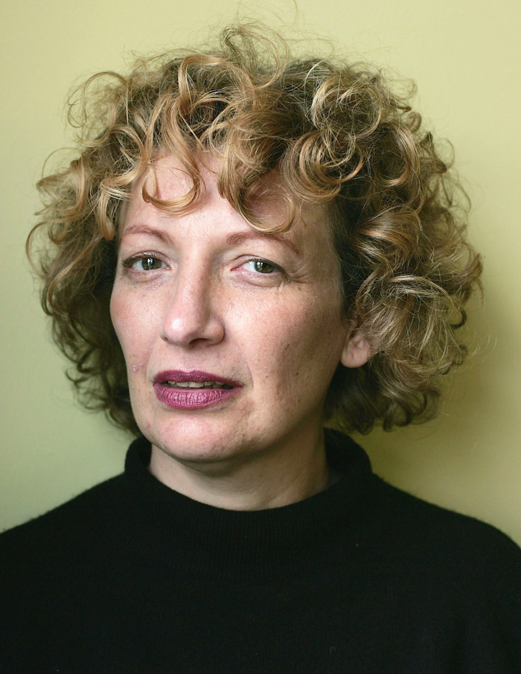

http://blog.omanoot.com/wp-content/uploads/2012/06/orly-castel-bloom.jpg

TELEVISION SPECIAL (2011, Hebrew) - 'Confessions of an Author in Crisis' - on being an author in Israel:

http://www.mako.co.il/tv-people/list-index/category1/Article-9866f682280d331006.htm

TELEVISION INTERVIEW - 'Inyan shel ta'am' ('A Matter of Taste,' Hebrew) (2012):

http://www.youtube.com/watch?v=w9_u9SWMo-0

TELEVISION SPECIAL - 'Bi-kri'a rishona' ('The First Reading,' Hebrew) - on *Dolly City* and motherhood:

http://www.youtube.com/watch?v=aKoemf_A2ZI